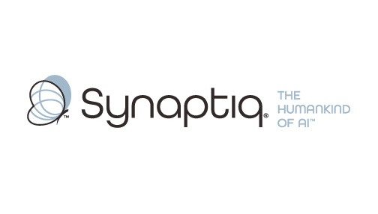
______________________________________________________________________
 | Stephen Sklarew  CEO & Co-Founder, Synaptiq  AI Strategy & Workforce Transformation | "The Humankind of AI"

Overview
Stephen Sklarew is a seasoned executive with over 30 years of experience specializing in enterprise-wide strategy, data governance, and AI transformation. As CEO of Synaptiq, he guides healthcare and insurance organizations in developing comprehensive analytics frameworks and AI governance structures through the proprietary AIQ® methodology. His expertise in Analytics Lifecycle Management and enterprise dashboard development has helped organizations like Medical Mutual create holistic KPI systems across diverse divisions. Stephen's approach emphasizes responsible AI adoption with strong governance foundations—perfectly aligned with the "humankind of AI" philosophy that prioritizes member-focused outcomes over technology for its own sake.
Background & Expertise
Stephen Sklarew is a seasoned business and technology executive with over 30 years of experience driving enterprise-wide transformation across healthcare, insurance, and regulated industries. His expertise spans strategic analytics implementation, AI governance framework development, and cross-divisional performance management systems. As CEO and cofounder of Synaptiq, an AI strategy and solutions firm founded in 2015, Stephen specializes in helping healthcare and insurance organizations develop comprehensive analytics ecosystems that unify KPIs across complex organizational structures.
Prior to his current role, Stephen held senior positions at companies like Sage Software, CEB (now Gartner), and Ernst & Young LLP, where he developed deep expertise in enterprise dashboard development, data governance, and regulatory compliance frameworks. His experience includes a venture-backed startup he cofounded, CircleBack (now SalesIntel), where he built SaaS products utilizing big data and machine learning for customer-facing applications—experience directly relevant to member engagement platforms.
Stephen has led technology and analytics initiatives across healthcare, financial services, and highly regulated industries, with particular strength in developing metric registries and governance committees that span multiple business divisions. Under his leadership, Synaptiq developed its proprietary AIQ® methodology, a comprehensive framework that guides organizations from AI readiness through enterprise-wide implementation. This approach emphasizes responsible AI adoption with robust governance structures—critical for healthcare organizations balancing innovation with regulatory compliance and member trust.
Stephen's philosophy of "The Humankind of AI" resonates strongly with member-focused organizations, emphasizing that technology should enhance human decision-making rather than replace it. His approach to enterprise analytics prioritizes transparency, explainability, and cross-functional collaboration—essential elements for organizations developing holistic performance tracking systems across diverse operational areas.
As a thought leader in healthcare AI and analytics governance, Stephen frequently shares insights on building enterprise-wide performance management systems that maintain regulatory compliance while driving innovation. He holds a BS in Biology from Virginia Tech, providing foundational understanding of healthcare and life sciences contexts.
Relevant Experience
- Healthcare Analytics & AI Governance: Led 9+ healthcare projects developing enterprise analytics systems, AI governance frameworks, and cross-divisional performance tracking solutions. Specialized in creating holistic KPI systems that span clinical, operational, and member experience domains while maintaining regulatory compliance.
- Enterprise Dashboard Development: Architected comprehensive enterprise dashboards integrating KPIs across multiple business divisions, with expertise in metric registry development and governance committee structures. Focus on creating unified performance visibility across complex organizational hierarchies.
- Data Governance & Committee Structures: Designed and implemented Analytics Lifecycle Management frameworks with formal governance committees, metric registries, and cross-functional oversight processes. Specialized in creating sustainable governance structures that evolve with organizational AI maturity.
- Member-Facing AI Solutions: Developed customer-facing AI applications and intelligent automation systems that enhance member experience while reducing administrative overhead. Experience includes chatbots, predictive analytics, and automated workflow systems for service organizations.
- Regulatory-Compliant AI Implementation: Led AI strategy and implementation projects in highly regulated industries, emphasizing explainable AI, compliance frameworks, and responsible automation. Expertise in balancing innovation with regulatory requirements and stakeholder trust.
- Cross-Divisional Strategy Integration: Facilitated enterprise-wide transformation initiatives that align technology strategy with operational goals across diverse business functions. Specialized in creating unified metrics that support both departmental autonomy and enterprise-wide visibility.

